Issue: Email notification of meeting is blank
This workaround applies only to Thunderbird.
There is an issue where the text of a meeting notification email is not being displayed in Thunderbird. Until a permanent fix is made, the following guidance applies.

Click on View->Message Body As
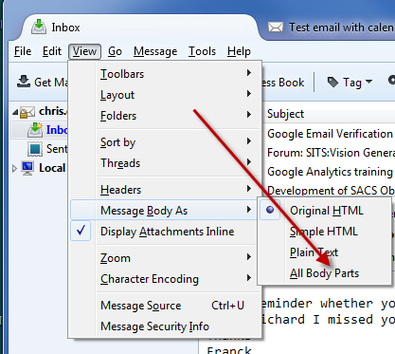

If ‘All Body Parts’ is in the list then by clicking this you should then be able to see the whole email message. Note: A side effect of this is that the body text will also appear as an attachment at the bottom of each message e.g.
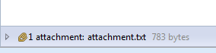

If ‘All Body Parts’ is not in the list then you need to install the ‘Show All Body Parts’ Add-on, as below.

Install ‘Show All Body Parts’ Add-on
- Click on Tools -> Add-ons:
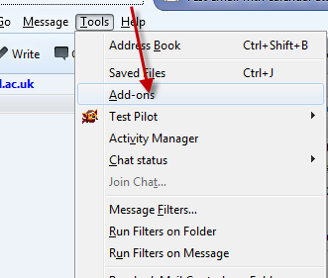

- Type ‘Show All Body Parts’ in search box and click magnifying glass:
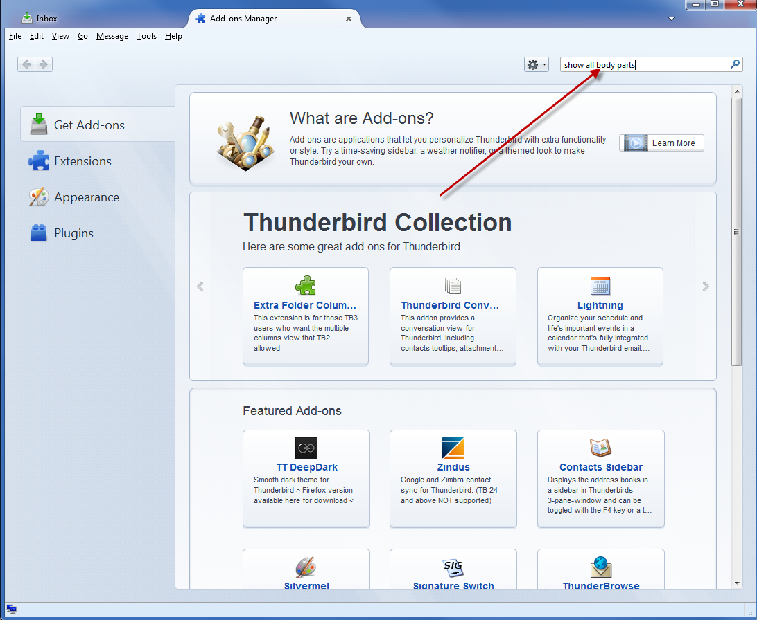

- Click Install
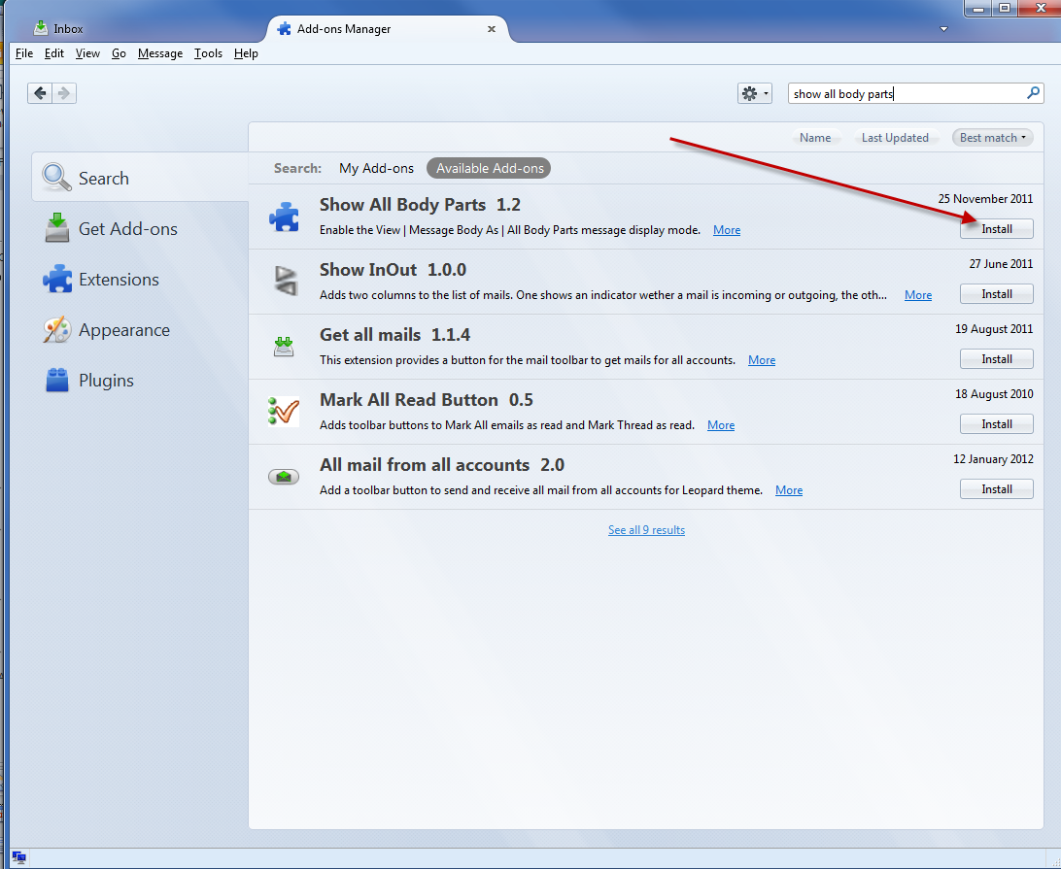

The ‘All Body Parts’ should now appear as an on the ‘View -> Message Body As’ menu.

