Extending Student VCR – User Guide

Generate VCR
To create a CAS/VCR record for an extending student you will need the student’s UUN
Go to ‘Generate Extending Student VCR’ in the ‘UKBA Processes’ container:
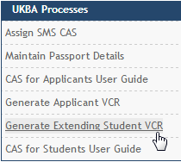
Enter the UUN then click ‘Generate VCR’
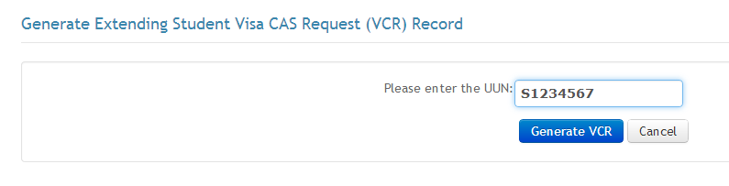
Click ‘Yes’ to generate the VCR
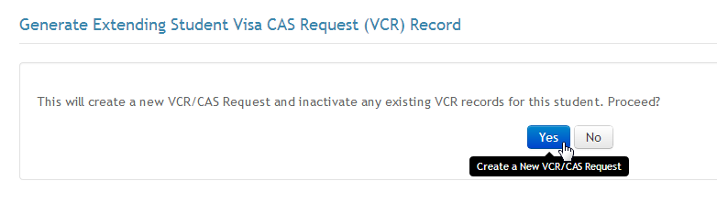

Click ‘View VCR’ to open the new VCR
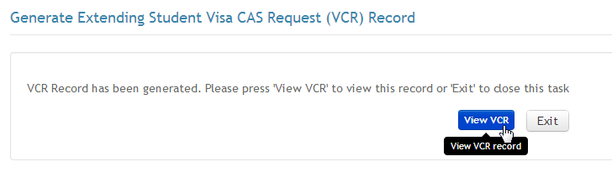
The VCR record is displayed and can be edited where required. Fields the need to be populated as data is missing will be shown in red.
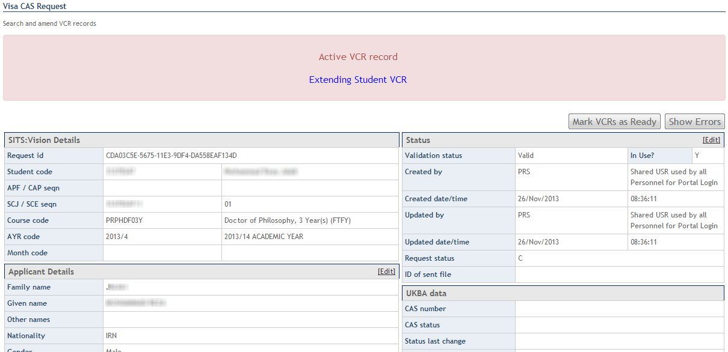

Extending Student VCR
Some fields are populated with values specific to an extending student VCR:

Course start date:
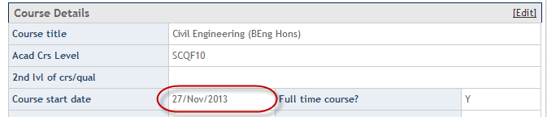
The course start date will be set as a future date as the SMS does not currently accept a value in the past for batch CAS requests.
The course end date will include an additional 4 months for Doctoral and MPhil students.
Course start and end date can be changed using the Edit function:
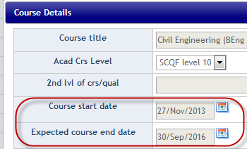

Evidence used to obtain offer:
The evidence field will show the actual course start date in the first line:
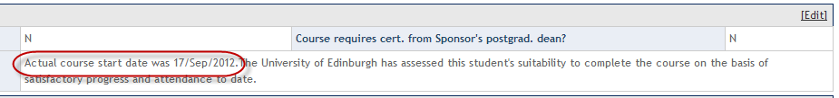
Where the student has been on their programme for more than 1 year the following text is included:
The University of Edinburgh has assessed this student's suitability to complete the course on the basis of satisfactory progress and attendance to date.
Where the student has been on their programme for less than 1year, the evidence from their application will be shown e.g.:
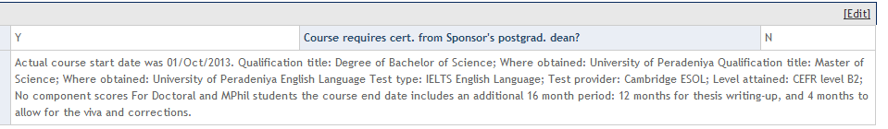
Where the student is on a doctoral or MPhil programme the following text is included:
For Doctoral and MPhil students the course end date includes an additional 16 month period: 12 months for thesis writing-up, and 4 months to allow for the viva and corrections.
The evidence field can be edited if required.

English Language:
Where the student has been on their programme for more than one year, English Language is populated as follows:
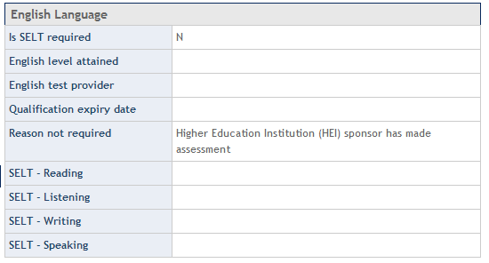
Where the student has been on their programme for less than one year English language will be populated using data from the application e.g.
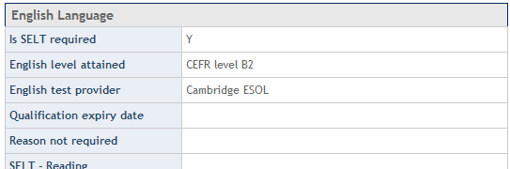

Progression Details:
Where progression information has been recorded as part of the application process then the details will be populated automatically.
If no data exists then the progression information will need to be added to the VCR:
Use the Edit function to do this:
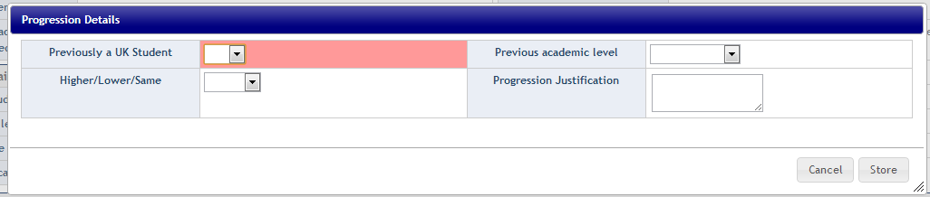

Financial / Accommodation:
‘1st year course fees’ will be populated with fees for the current year.
The ‘Course fees paid’ field should be populated manually (use the edit function).
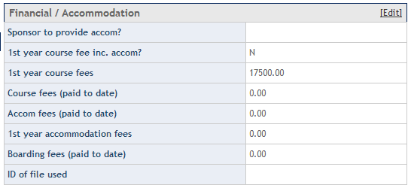
1st year course fees value can be edited if required.
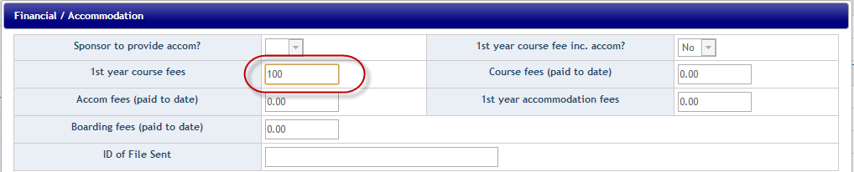

Retrieving a VCR
You can come back to an extending student VCR through the existing ‘Assign SMS CAS’ option:
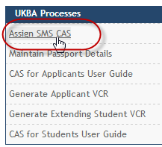
Enter the UUN and retrieve the record. All VCR records for the student will be returned, the extending student VCR will be identified at the top of the screen:
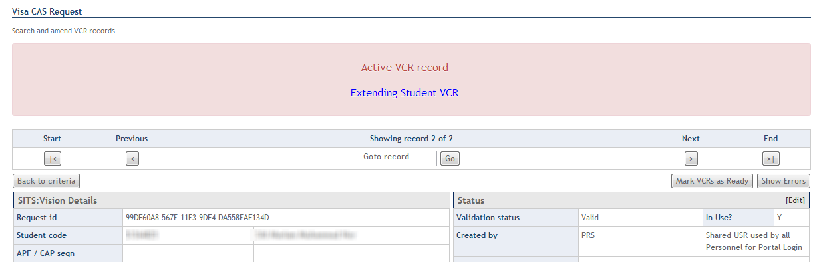
Note: All active VCR records will show the red ‘Active VCR banner’

Re-Create VCR
If you need to re-create a VCR (if some of the data which cannot be edited is incorrect for example), then retrieve the existing VCR (as shown above).
In ‘Status’ click Edit
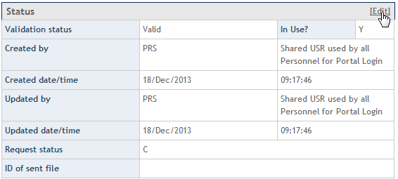
Set the ‘Request Status’ to ‘Cancelled Before Sending’ and then Store
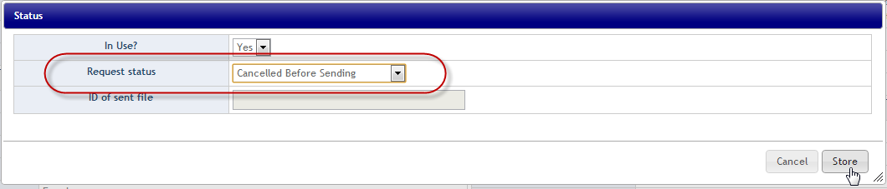
You can then create a new VCR using ‘Generate Extending Student VCR’.
Note: A refresh function will be delivered early 2014

CAS Request
Once all data in the VCR is correct, then it should be marked as Ready:
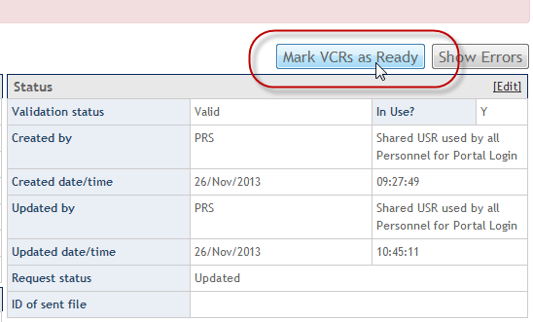

CAS Notifications
The student VCR will be processed in the same as an applicant VCR. The data is exported twice daily by SACS Support to the UKBA and a CAS number will then be imported from the SMS.
The CAS number will be sent to the student by email automatically once it has been imported from the SMS. The email is sent to the student’s University and Personal email addresses.
A copy of the email will be sent to the staff member who marked the VCR as ‘Ready’

