External Examiners
Interim Input Facility Guidance Document

Overview
The External Examiner Project has developed screens to provide a simple data entry facility for use by College and School staff to enter External Examiner contact and appointment details for all current external examiners.
Please note there are prerequisite steps that must be completed for each External Examiner prior to accessing these screens:-
- The External Examiner must be registered on the Visitor Registration System
- Student Systems Operations must have created an account for the External Examiner within Euclid (Send VRS id & full name of examiner to studentsystems@ed.ac.uk)

Functional Description
The new container entitled ‘External Examiners’ will be available to staff whose schools have requested access to the External Examiners Data Entry process. Access requests are to be sent to Students Systems Operations (studentsystems@ed.ac.uk).
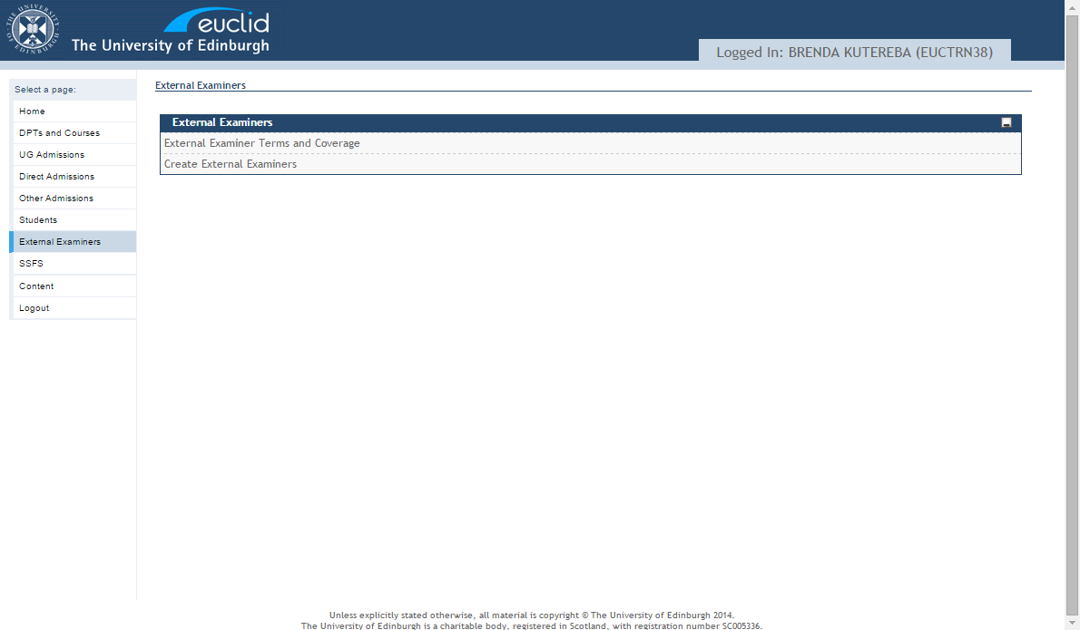

Option 1:- Create External Examiners
This option allows the user to add External Examiner details, presenting the search facility first:-
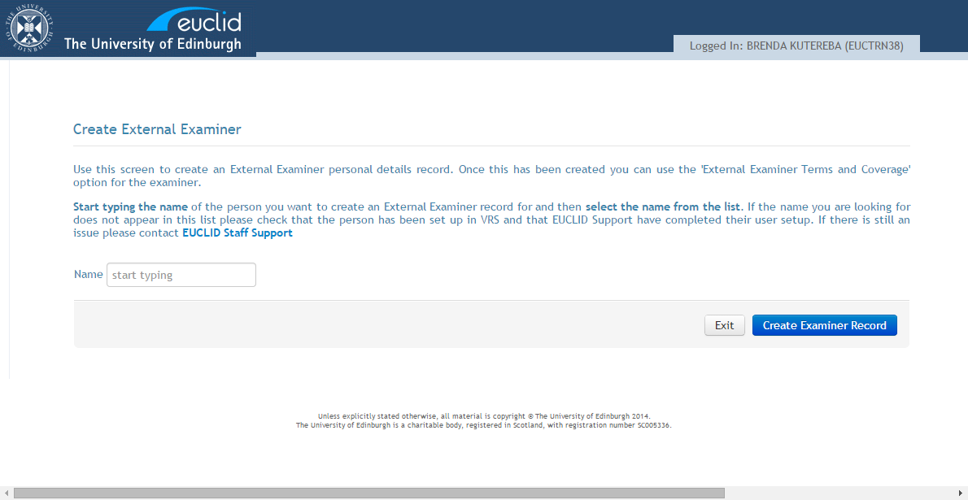
Follow the guidance provided on the screen, select the external examiner name and select button ‘Create External Examiner’ and the user is presented with the data entry screen for examiner contact details.

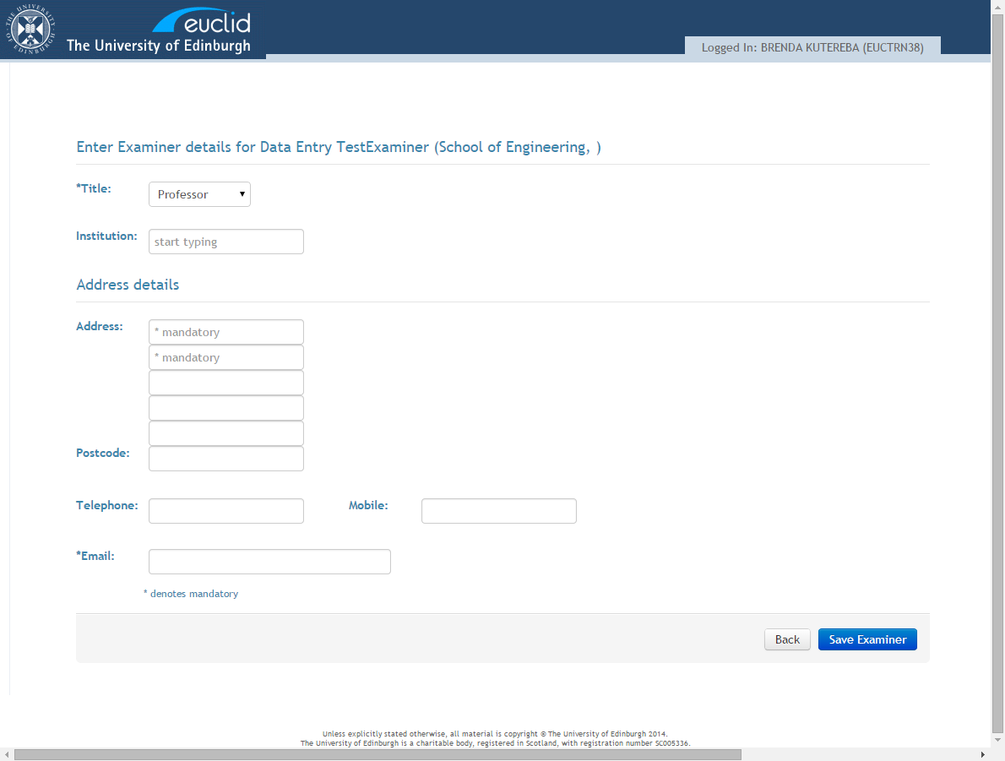
Simply complete the details and select ‘Save Examiner’ to create the External Examiner record.
You will be presented with confirmation that the External Examiner has been added successfully:-
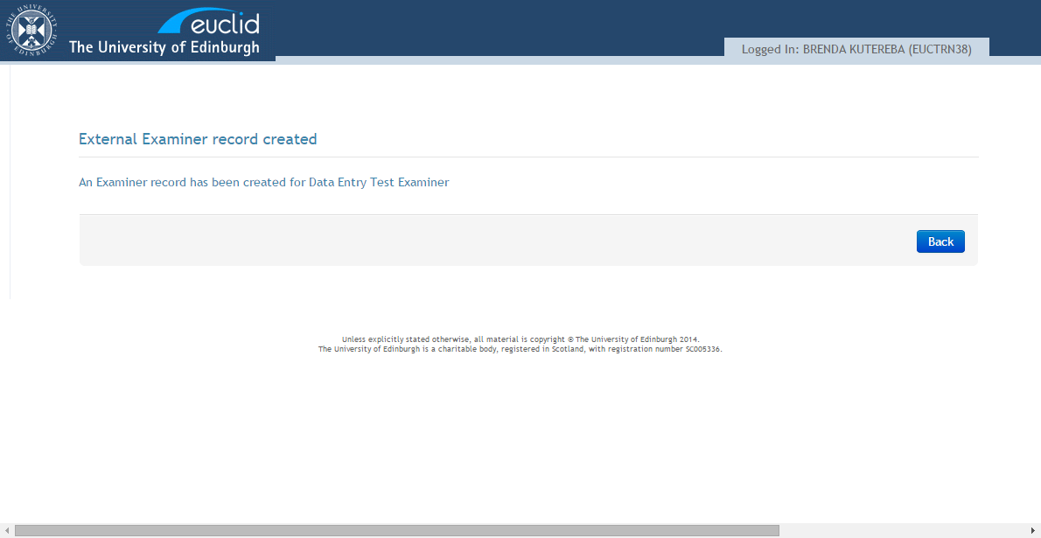

From here you can go back to the search facility and enter the name of the next examiner:-
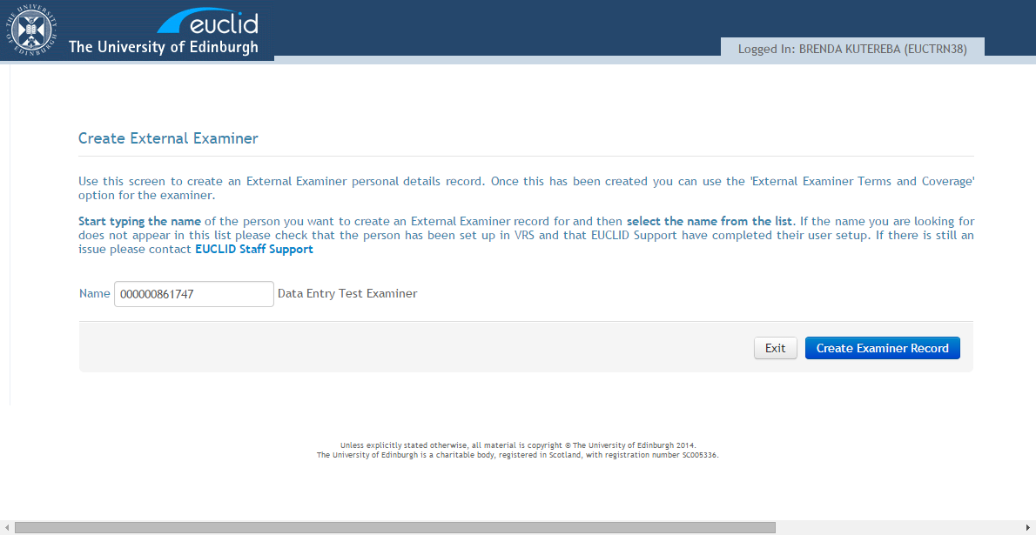

or select exit to return to the external examiner options:-

Option 2:- External Examiner Terms and Coverage
This option allows the user to add the appointment term and coverage details for an examiner, presenting the search facility first:-
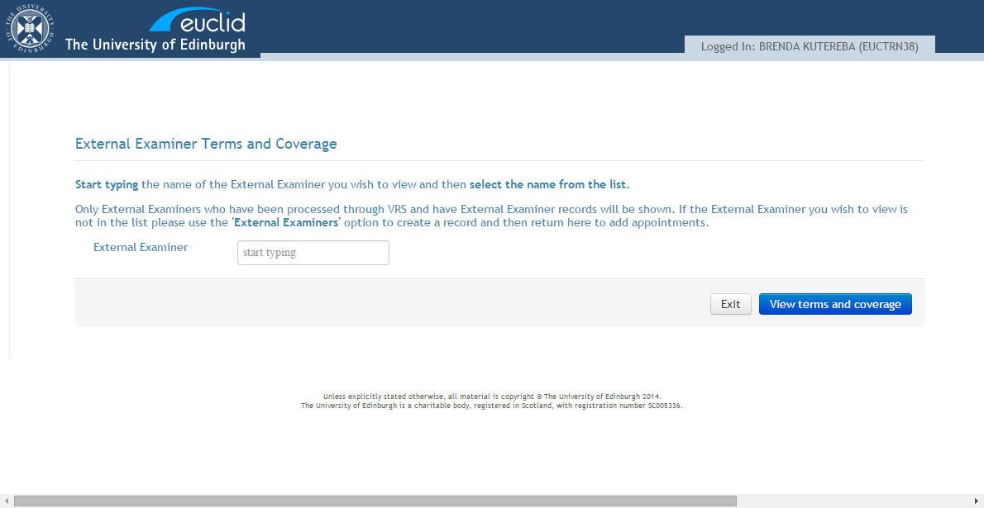
Follow the guidance provided on the screen, select the external examiner name and select button ‘View terms and coverage’ and the user is presented with the examiner’s current terms and coverage at the top of the screen, with any coverage listed below.

Where there is not any term or coverage detail recorded for the external examiner, this is displayed.
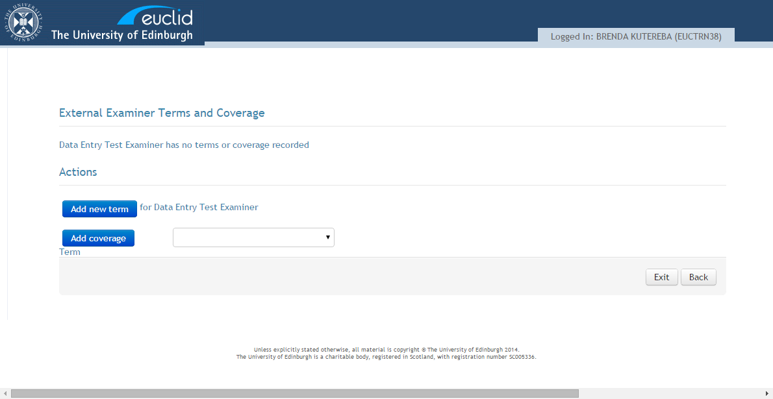

The user can select to add a new term for the external examiner.
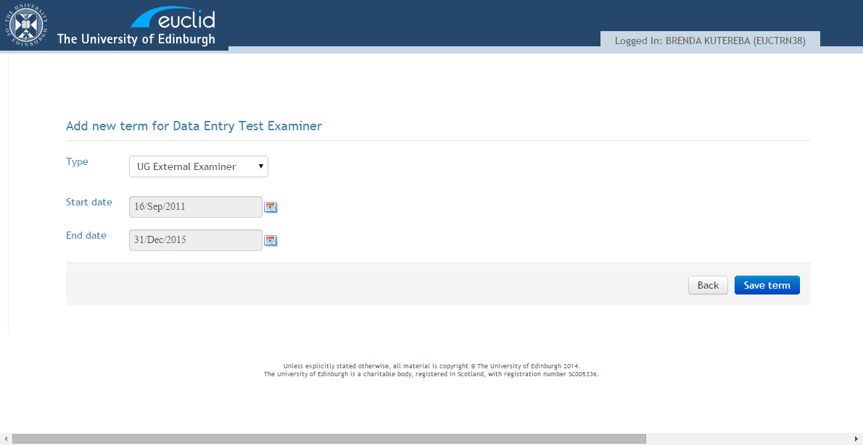

All fields are mandatory.
Start date and end date must be selected from the date picker.
The user can select to:
- go ‘Back’ to the External Examiner terms and coverage screen without saving
- ‘Save term’. This will create External Examiner appointment term details. The user will be returned to the External Examiner terms and coverage screen, and will see the new term displayed.
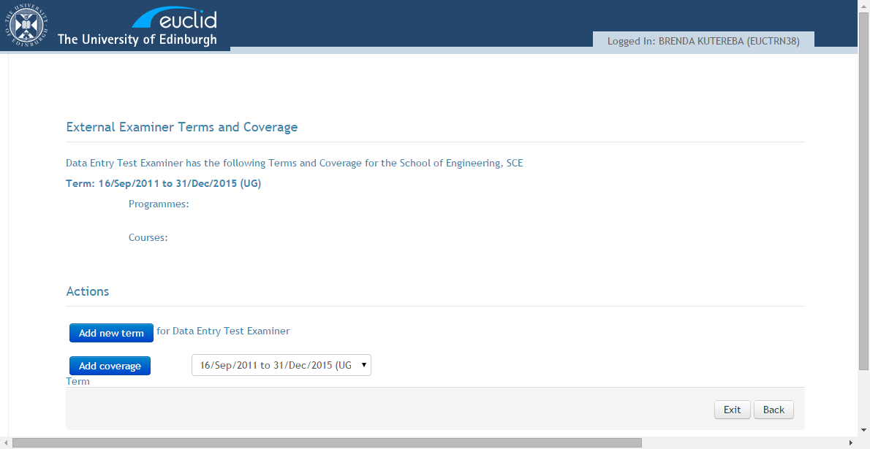
The user can select to add coverage. The user must select which term to add coverage to from a dropdown of current terms for the examiner.

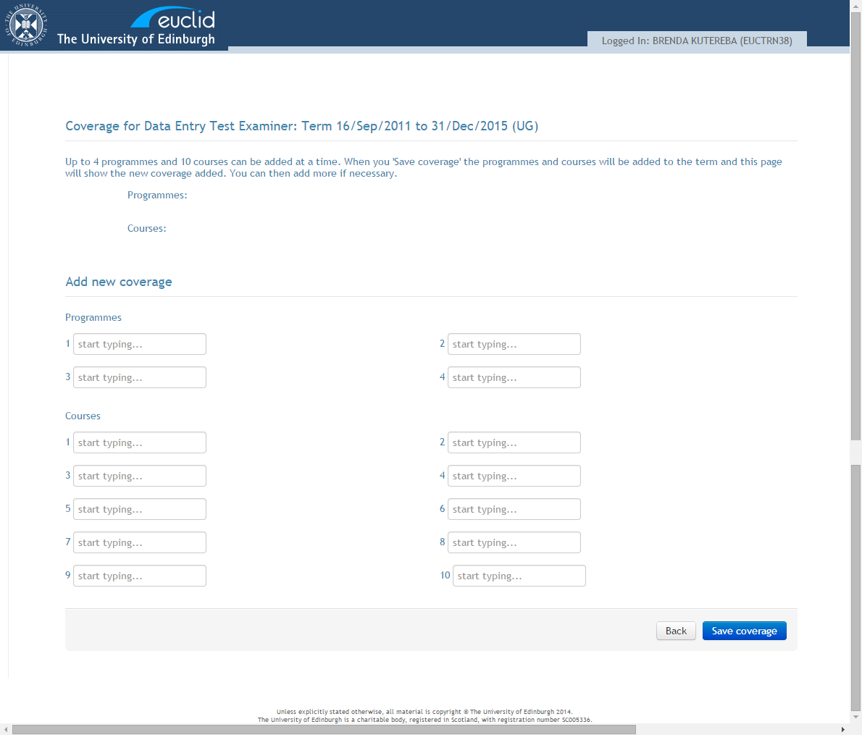
Current coverage for the selected term will be displayed at the top of the screen.
All editable fields on this screen are dynamic list boxes.
There is the facility to record 4 programmes and 10 courses at a time. If more are required then the user can use this screen multiple times until all of the coverage has been entered.
The user can select to go ‘Back’ to the External Examiner terms and coverage screen without saving, or to ‘Save coverage’.
Selecting to ‘Save coverage’ will create External Examiner coverage records. The user will be returned to this page and will see the new coverage in the top section of the screen.
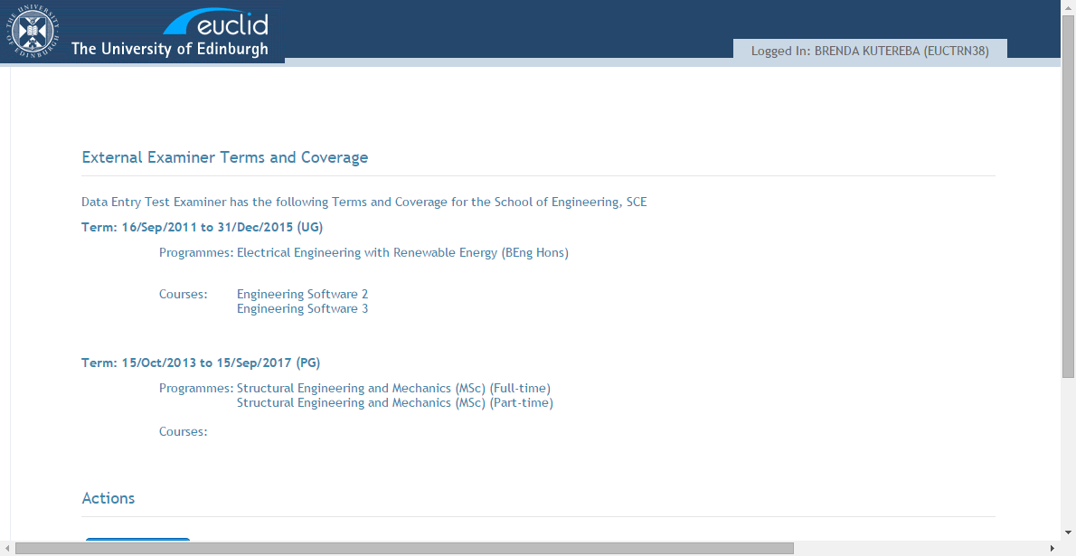

If the user selects ‘Save coverage’ but has not selected any programme or course they will be returned to this page with no updates.

