Uploading Student Engagement Events by File

Step 1 – Download the student engagement CSV file template
You can download the student engagement CSV file from the Student Systems – Student Engagement Monitoring web site.
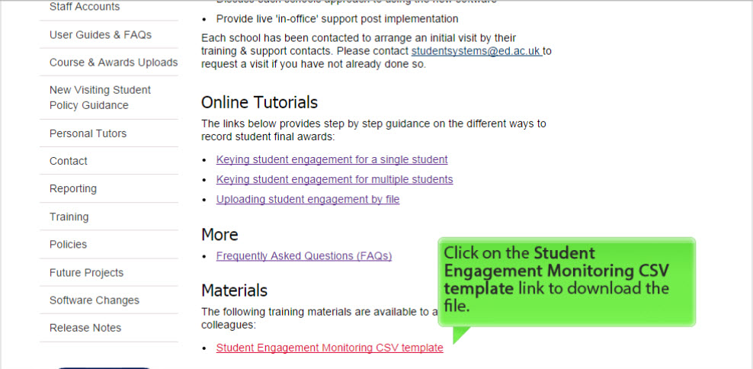
Step 2 – Create a student engagement CSV file for upload to EUCLID
Open the Student Engagement CSV file template previously downloaded from the Student Systems web site (see Step 1).
Download and copy the course or programme student UUN from the Business Intelligence Suite Class List reports within the following folder:
My Documents/Folders/Public Folders/SASG : Student Systems/Student Systems Developed and Maintained/Engagement Monitoring
Paste the student UUN into the CSV file UUN column.
Manually key in the remaining columns:
Column | Mandatory | Data
Event Type | Y | See event type codes in FAQ
Event Date | Y | dd/mm/yyyy
Organiser | N | Leave blank
Attended | N | Y, N, E (Yes, No, Exempt)
Description | Y | Free text
Notes | N | Free text

An example can be seen below:
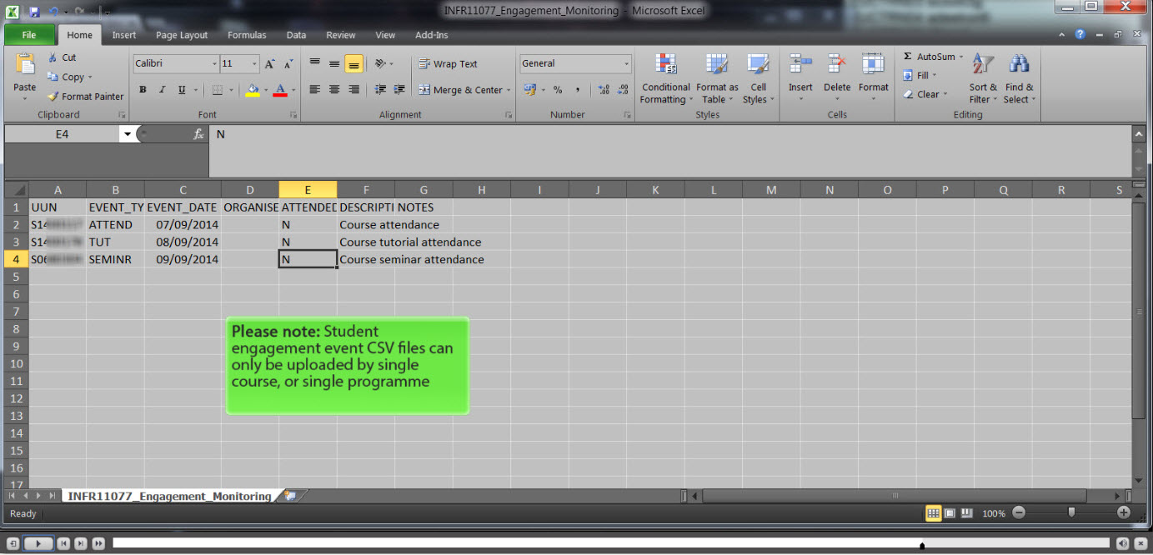
Save the CSV file.
Step 3 – Upload a Student Engagement CSV file into EUCLID
Open EUCLID.
Click on the Upload from File Student Engagement Events link within the Student page.
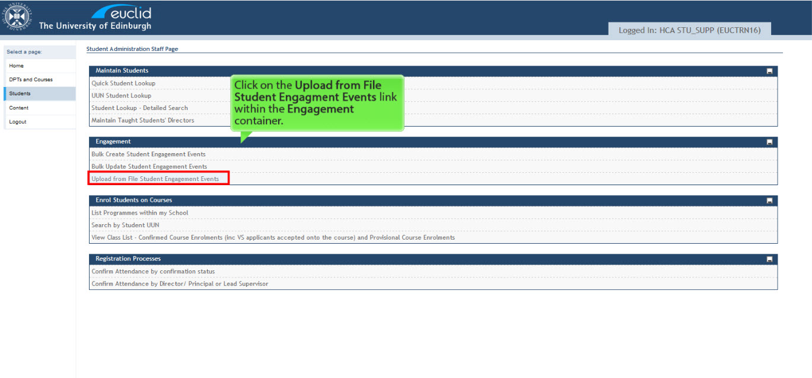
Select the level of your engagement events at Course Level or Programme Level:
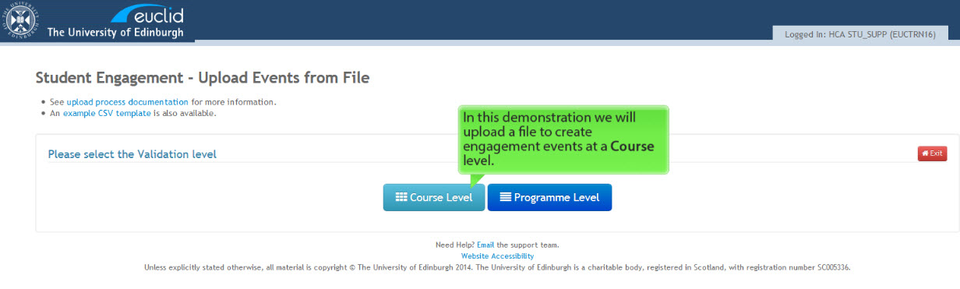
Key in the title of the Course or Programme that you wish to upload engagement events for:
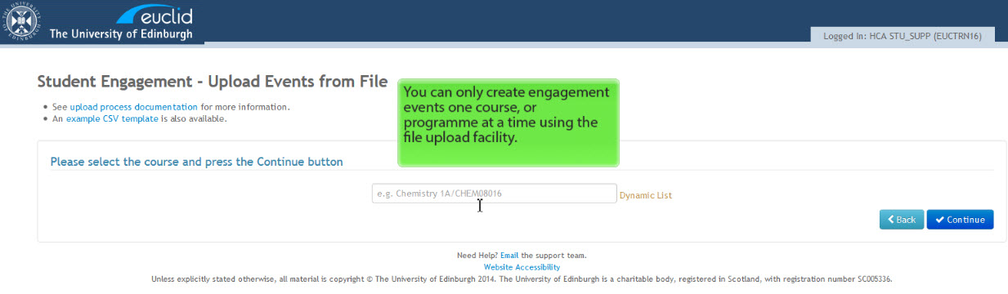
Click on the button.
Browse and select your CSV engagement event file:
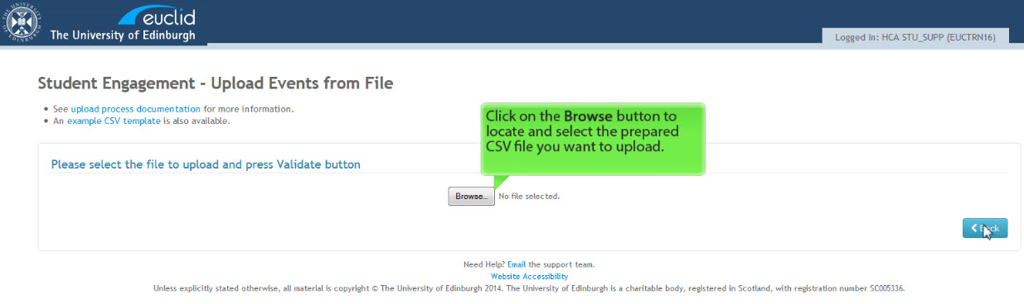
Click on the button.
Step 4 – Create student engagement events for multiple students
On uploading your CSV file you will be presented with the validation results. An example can be seen below:
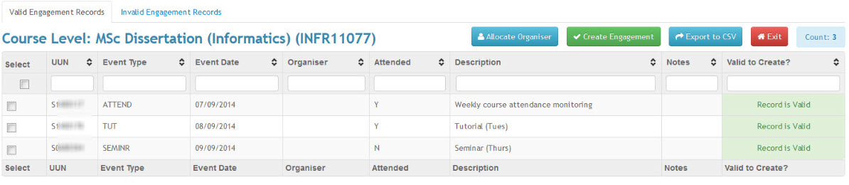
You can create engagement events for your Valid Engagement Records, but not the Invalid Engagement Records.
To find out more about fixing invalid engagement records within your CSV file, click on the link below:
- How do I resolve invalid student engagement data in EUCLID after a CSV file upload?
Select the valid records you want to create within EUCLID:
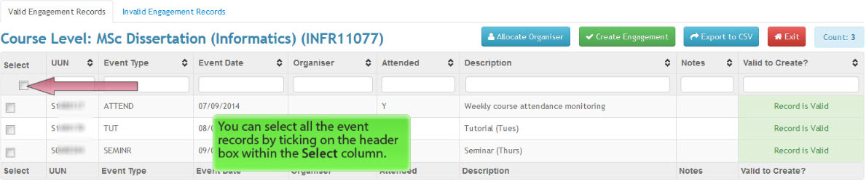
Click on the button.
This will create engagement events for the valid engagement records within your CSV file.
A Success banner will appear and the screen refresh to remove the engagement records for the list:
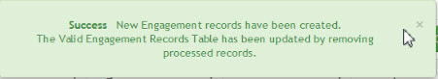
You have now successful complete uploading engagement events via the CSV file upload facility.

